|  |  |
| --- | --- |
| **Date**  **Team ID**  **Batch ID**  **Project Name** | **05 Nov 2022**  **PNT2022TMID08561**  **B5-5M1E**  **Customer Care Registry** |

***Step 1 : Install Python 3.11.0 , pip ,IDLE***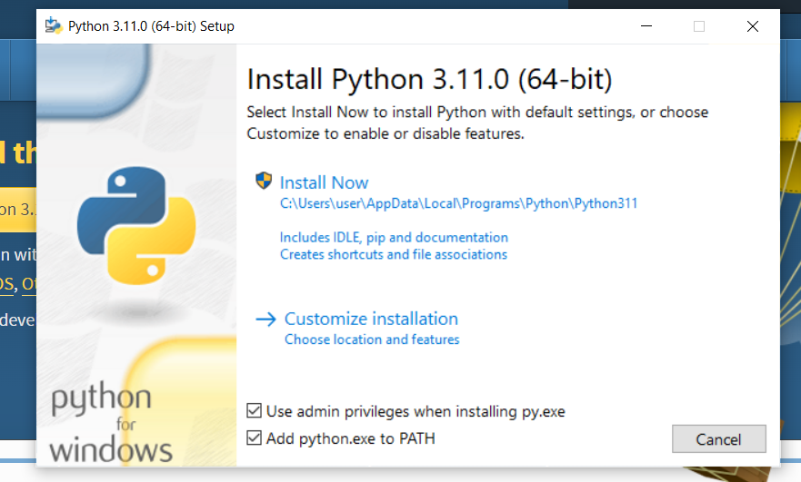

***Step 2 :Verify Installation*** 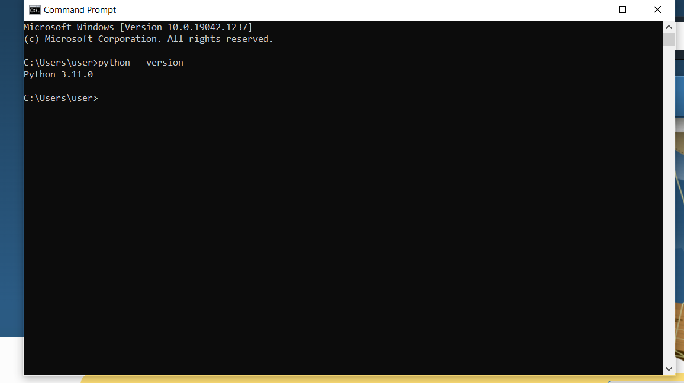

***Step 3:Cheacked on IDLE***

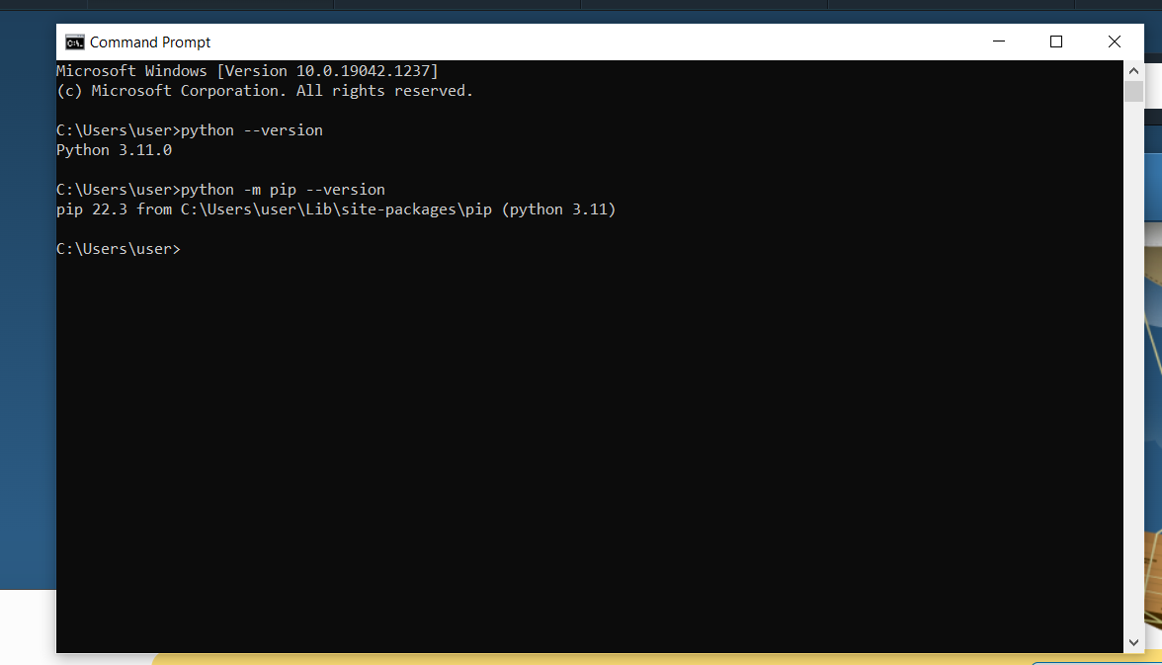

***Step 4:Install Flask And Final Stage***

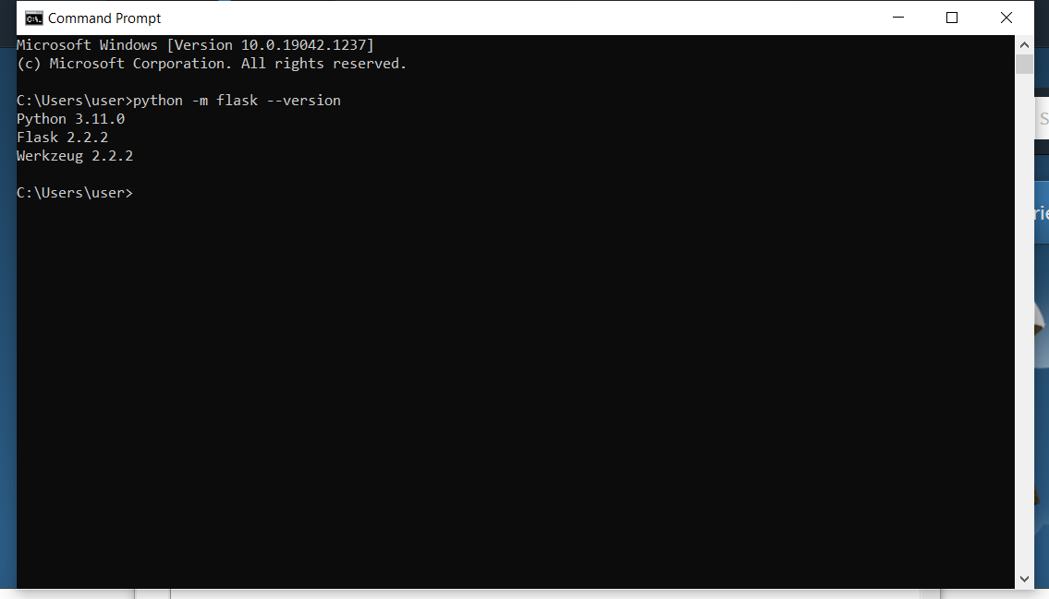

***Sample Program***

From flask import Flask

App = Flask(_name_)

@app.route(‘/ ‘)

Def hello_world():

Return ‘ HELLO,WORLD!’

If _name_==”_main_”:

app.run()

***output***

HELLO WORLD